**Karan Arora**  **R.L. Institute M: 9416974837**

**Max Time : 1 hr** **Class = 12th Chemistry Test Max Marks : 30**

**Haloalkanes and Haloarenes – 1**

1. Multiple choice questions : [ 1 X 5 = 5]
2. Ethylene chloride is a/an ___________.

|  |  |  |  |
| --- | --- | --- | --- |
| a) Allylic halide | b) Vinylic halide | c) vic-dihalide | d) gem-dihalide |

1. Arrange the following compounds in increasing order of their boiling points.

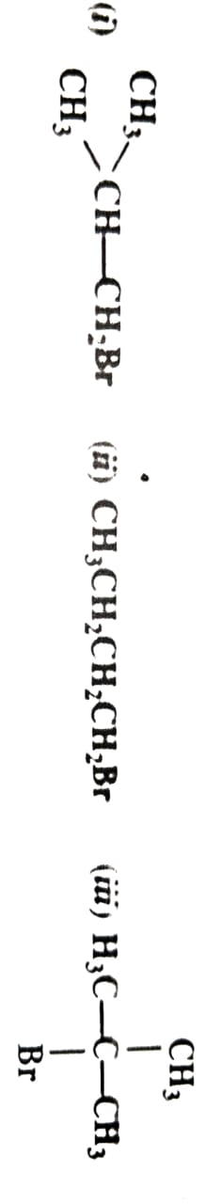

|  |  |  |  |
| --- | --- | --- | --- |
| a) (i) < (ii) < (iii) | b) (iii) < (ii) < (i) | c) (iii) < (i) < (ii) | d) (ii) < (i) < (iii) |

1. Which of the following is vinylic halide?

|  |  |  |  |
| --- | --- | --- | --- |
| a) | b) | c) | d) CH3CHCHCH2Br |

1. Which is the correct IUPAC name for

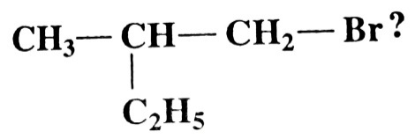

|  |  |
| --- | --- |
| a) 1-Bromo-2-ethyl-2-methylethane | b) 1-Bromo-2-methylbutane |
| c) 1-Bromo-2-ethylpropane | d) 2-Methyl-1-bromobutane |

1. Which of the following is an example of vic-dihalide?

|  |  |
| --- | --- |
| a) Allyl chloride | b) Ethylidene chloride |
| c) 1 , 2 – dichloroethane | d) Dichloromethane |

1. Write the structure of the major organic product in each case of the following reactions :

[ 1 x 5 = 5 ]

|  |  |
| --- | --- |
| (i) CH3 CH2CH2 Cl + NaI | (ii) CH3 CH2 Br + KCN |
| (iii) C6H5 O Na + C2H5 Cl | (iv) CH3 CH2CH2 OH + SOCl2 |
| (v) CH3 CH C (CH3)2 + HBr |  |

1. Arrange the compounds of each set in order of reactivity towards SN2 displacement:

[ 1 x 3 = 3 ]

1. 2-Bromo-2-methylbutane , 1-Bromopentane , 2-Bromopentane.
2. 1-Bromo-3-methylbutane , 2-Bromo-2-methylbutane , 2-Bromo-3-methylbutane.
3. 1-Bromobutane , 1-Bromo-2,2-dimethylpropane , 1-Bromo-2-methylbutane , 1-Bromo-3-methylbutane.
4. How the following conversions can be carried out? [ 1 x 3 = 3 ]

a) Propene to propan-1-ol b) Ethyl chloride to propanoic acid

c) But-1-ene to n-butyl iodide

1. Give one example of the following : [ 2 ]

a) Williamson synthesis b) Mendius reduction

1. Convert Prop-1-ene to butanal. [ 2 ]
2. (i) Which alkyl halide from the following pair is chiral and undergoes faster SN2 reaction? [ 2 ]

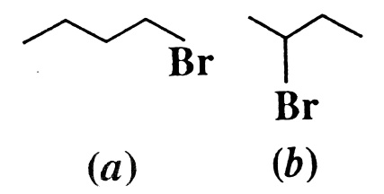

(ii) Out of SN1 and SN2 , which reaction occurs with Inversion of Configuration.

1. Predict the order of reactivity of the following compounds in SN1 and SN2 reactions : [ 2 ]

C6H5 CH2 Br , C6H5 CH (C6H5) Br , C6H5 CH (CH3) Br , C6H5 C (CH3) (C6H5) Br

1. Explain Hoffmann ammonolysis with suitable example. [ 3 ]
2. Identify a , b and c in the following : [ 3 ]

CH3 CH2 Br b c CH3 CH2 COOH